Instructions for change agent attribution using

LandTrendr Attribution Interface, Version 1.0

We are interested in determining what agents have caused changes on the landscape. To do this, we use an interface that allows us to document the processes causing change in individual patches identified by a separate algorithm. In addition to noting what caused the change, we attempt to describe what the land was like before, immediately after, and long after the change. These pieces of information will be used to train an algorithm to mimick the human interpretation for other patches where a person has not yet looked.

Instructions:

1. Log in to the LandTrendr attribution interface
   1. <http://timesync.forestry.oregonstate.edu/ltattribution/public/bin/>
      1. If you have not registered, you must set up a user account with Zhiqiang Yang: [zhiqiang.yang@oregonstate.edu](mailto:zhiqiang.yang@oregonstate.edu). Expect the turnaround time to be several days minimum.
   2. You’ll see an interface like this:

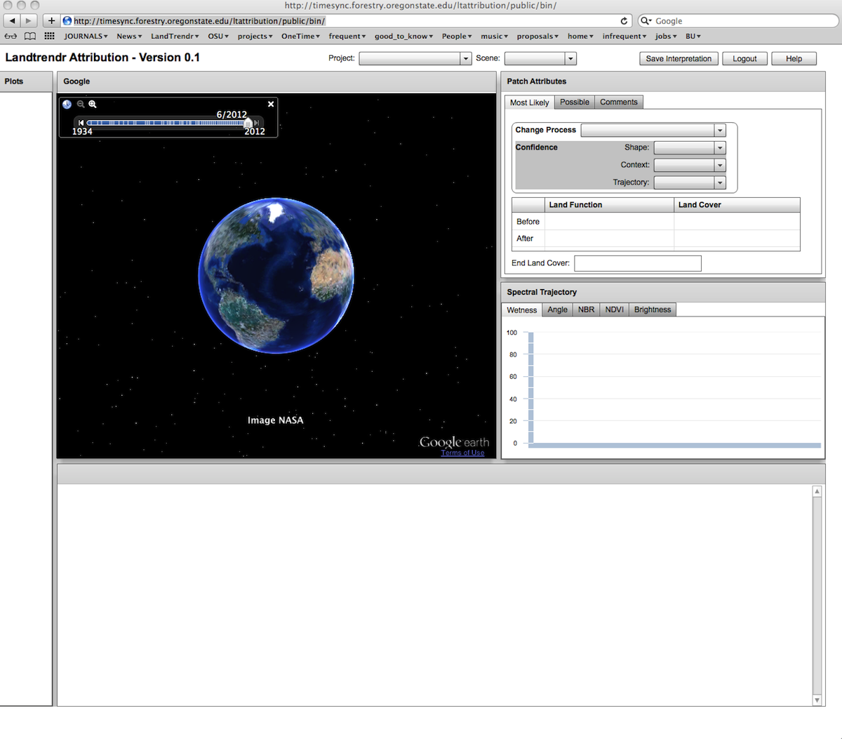

1. In the top center, select the “Project” you are working on, then select the “Scene”
   1. If you don’t know the project you’re on, you may not belong here…
   2. The “Scene” is the Landsat path/row. Some projects span multiple path/rows, so we need to specify which one we are focusing on.
2. Once you’ve selected those, you’ll see the possible list of plots on the lefthand side of the window:

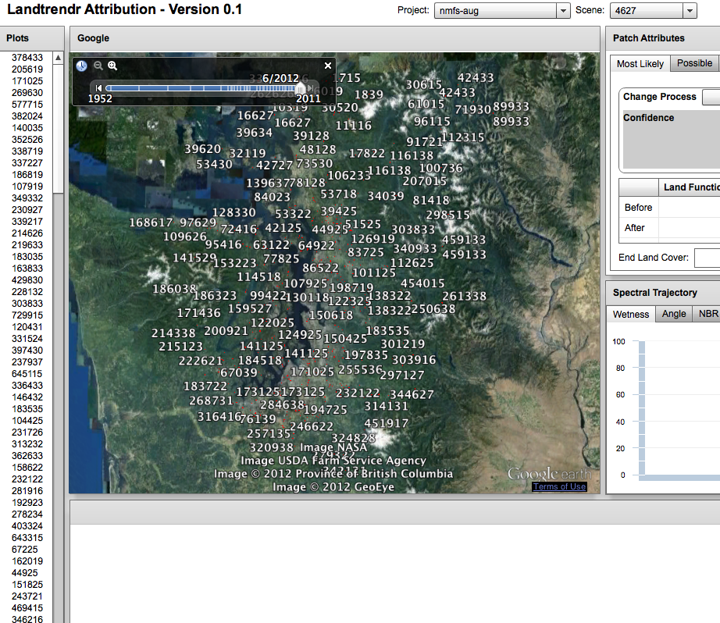

1. Select a plot by clicking with the mouse, and suddenly a lot of the interface will become populated. (see below). There are four main components to the interface, which we’ll discuss in sequence: the GoogleEarth interface (upper left), the patch attributes database (upper right), the Landsat image chips (bottom), and the spectral trajectory window (middle right).

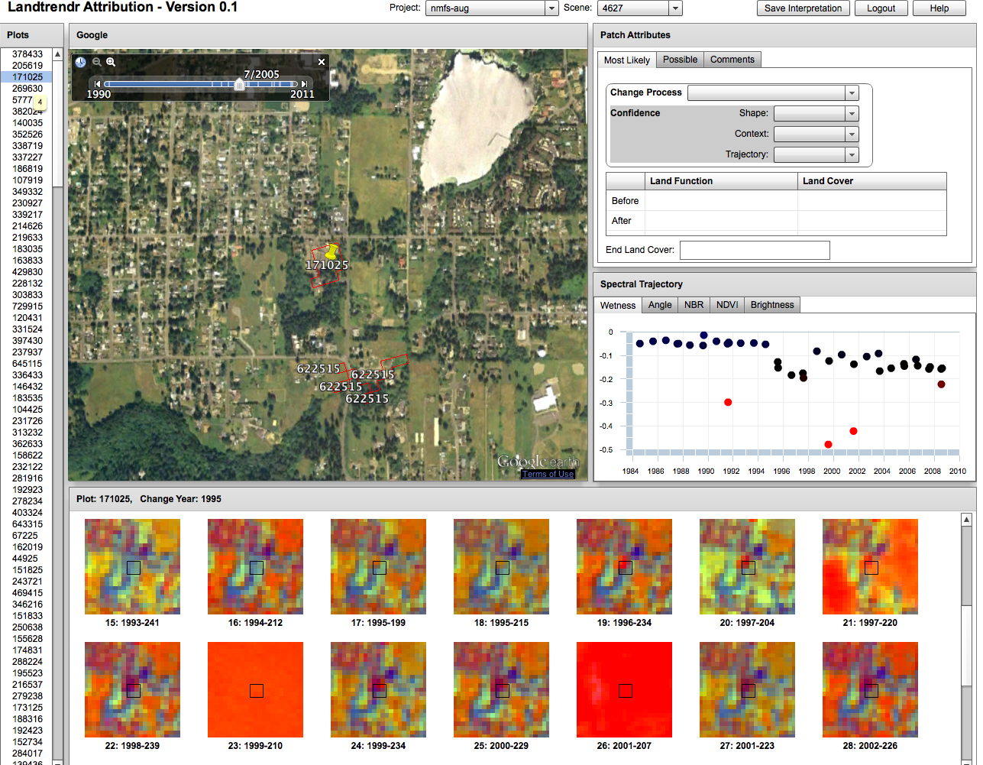

1. GoogleEarth Interface:
   1. Here, you can see the polygon of interest overlaid on airphotos (both recent and historical).
   2. Use the slider bar at the top to see historical photos.
   3. You can tilt, zoom, pan, etc. as with normal GE.
   4. Key purpose: To asses the Shape and Context of the polygon relative to the ground.
2. Patch attributes database (upper right)
   1. Here, you enter the data about what happened in the patch. There are drop-down menus for the data you enter.
   2. Your selections get saved if you click on “Save Interpretation” or if you move on to a different plot.
   3. More on the rules for assigning these later.
3. Trajectory window (middle right)
   1. This shows the spectral trajectory of the center point of the patch. That center point is represented by the little square box in the chip windows.
   2. The spectral trajectory quantifies the story of the patch from Landsat’s perspective. Different indices can be selected using the tabs (i.e. Wetness, Angle, NBR, etc.). These may tell slightly different stories.
   3. If you need to zoom into a particular Y-value range, either right-click and select “plot stretch” or left-click and drag a box to define the new bounds of Y values.
4. Chip windows (bottom)
   1. Note that the year where a change is claimed by the algorithm is noted just above the plot windows, in the upper left.
   2. These are extractions of all of the Landsat data we have in our stack.
   3. Use the roller on your mouse to zoom in or out.
   4. Color interpretation requires that you know how to interpretation Tasseled-cap imagery. Generally speaking:
      1. Barren/rock/soil is red
      2. Water is blue
      3. Urban is generally purple
      4. Snow/rocky snow/glaciers are purple, magenta, dark red
      5. Clouds are bright red or magenta
      6. Conifer forest is blue
      7. Broadleaf forest is yellow, yellow-green.
      8. Mixed forest is cyan or green cyan.
      9. Herbaceous fields and ag can be various shades of yellow or green or blue if they have vegetation, or red/orange when plowed.
   5. The dates of the image are in the format YYYY-DDD, where DDD is the julian day of year (starts with 1 on January 1st).
5. **Interpretation rules** 
   1. Overall strategy:
   2. We want to describe the process that has caused a change on the landscape, and we want to record as much as possible about that change to help improve our algorithms that will be based on your interpretations. We want to know what was there before the change, after the change, how confident you are in your call, and why.

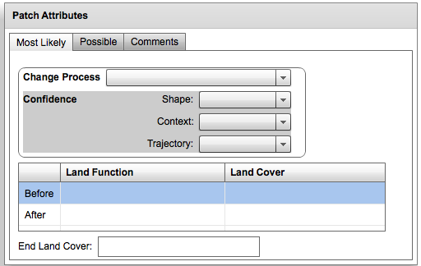

* 1. Tabs: Most Likely, Possible, Comments
     1. In most cases, you should only populate the “Most Likely” tab. However, if the change process is ambiguous and could equally be one of two things, use the “Possible” tab to enter the secondprocess.
     2. Comments:
     3. The comments section is important. We like comments. Also, several kinds of change process require more information. If you select “false change” as the change process, select the reason that you think the change occurred (snow, phenology, cloud/shadow, misregistration). Also, if the patch is right, but only captures some of the overall change process, or is labeled in the wrong year, click those boxes.

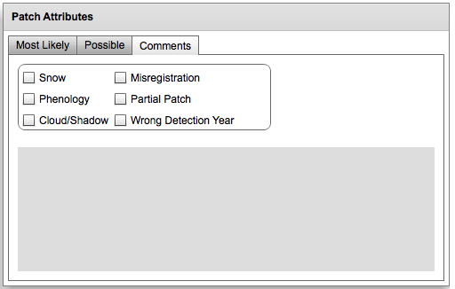

* 1. Change processes:
     1. The key strategy here is to capture the intent or the reason for the change. Separately, we’ll capture the effect of that change on the land cover, etc.
     2. Clearcut
        1. Silvicultural treatment aimed at removing nearly all trees from the site. If a handful of “leave trees” are left, still a clearcut, but otherwise it must be completely clear of the original overstory.
     3. Partial harvest
        1. Silvicultural treatment aimed at removing only some of a stand. This is a broad category of “anything that isn’t a clearcut.” We do not use strict percent-cover cutoffs any more.
     4. Development
        1. The purpose of the change was to build structures or impervious surface. This applies even if it was a forest harvest that resulted in only one house being built.
     5. Fire
        1. The dominant process was a fire: wildfire or prescribed fire. Occasionally, a clearcut will be followed by a burn, but unless that fire is captured separately (as indicated by the year of the change), that would be clearcut.
     6. Insect/Disease
        1. Mountain pine beetle, budworm, root rot, etc. are all possible agents of change.
     7. Road
        1. If the purpose was primarily to build a road, then this is the change process. If, however, the road was part of a larger clearing process within the patch, either for a clearcut or a housing development, then put the change in those categories, not road.
     8. No visible change
        1. We want to know when the algorithm is making bad calls. Here, we record when we can find no evidence for any change having occurred, and we can’t figure out why the algorithm might have been tricked.
     9. False change
        1. Here, on the other hand, we think we can see why the algorithm got fooled into a false change. A common example is when a cloud or snow is visible in an early or late-dated image, and causes an apparent spectral change picked up by the algorithm.
     10. Unknown agent
         1. This is unusual, but it is possible that there is a change that is visible in the photos, chips, and/or trajectory, but you have no idea what the actual process was that caused it. Thus, the change is real, but your ability to label it is stymied.
     11. Water
         1. Any water-based erosive process, including inundation or flood.
     12. Wind
         1. Windthrow in forest.
     13. Avalanche: Chute
     14. Avalanche: Runout
         1. Avalanches have two distinct phases with different shapes, and thus we keep them separate. The “chute” is the narrow portion on the steep gradient of the mountain; the “runout” is the often globular patch of vegetation disturbance that happens at the base of the avalanche when it hits the valley.
     15. Debris flow
     16. Landslide
         1. According to <http://geology.com/articles/debris-flow/>,

“Debris flows differ from slides because they are made up of "loose" particles that move independently within the flow. A slide is a coherent block of material that "slides" over a failure surface. “

* + - 1. To qualify as a landslide, we will use the rule that the block of material that moved must still be visible as a coherent unit. If not, we consider it a debris flow.
    1. Other
       1. A catch-all. If you choose “OTHER”, you MUST enter the change in the “comments” section, with some good description of what you think it is.
  1. Confidence:
     1. When determining what caused a change, there are three broad characteristics you use: shape, context, and trajectory. For each, we want to know how much that characteristic helped you make the call about the change process, and how appropriate that characteristic is for the change process of interest.
        1. Shape: Based primarily on the airphotos.
           1. High confidence: You can interpret the airphoto before and after the apparent change, and the shape of the polygon matches well with the changes caused by the process. Interpretation of the airphoto is key here: For example, an insect-caused mortality event would get a high score if you could see live trees in photos before the change and dead trees after the change.
           2. Medium confidence: You can interpret the airphoto well only after or before the change, but the shape and the condition at that point in time are consistent with the change process you claim.
           3. Low confidence: The airphoto interpretation does not help assess the change process, either because it’s ambiguous, unavailable, or because the polygon’s shape doesn’t match with what’s on the ground in the photo.
        2. Context: Based on the airphoto, the image chips, and your knowledge of the landscape.
           1. High Confidence: The change process is occurring in a part of the landscape where it is expected, and you can corroborate that by interpreting both the photo and the imagery. In some cases this will be the function of the surrounding area (say, a development occurring in an area where other urban developed areas exist) or by clearer indications of the change process occurring nearby (say, a plot appears to have low-level disturbance that could be partial cutting by people or low-intensity fire, but by looking at the context, you see it was next to a large fire in the same year that burned hotter nearby).
           2. Medium Confidence: The change process is probably occurring in a place where it is expected, but your ability to assess that is hampered by either difficulty interpreting the surrounding area, or by lack of knowledge of the change process within that landscape. For example, timber harvest can sometimes occur near developed areas. It’s unclear, at times, whether it is harvest or not, and the surrounding area doesn’t give much help.
           3. Low Confidence: The change process seems inappropriate to the surrounding area, or simply is uninformative. It’s possible to be confident about a change process, but not to rely on the context at all for making the call – in this case, select “low confidence” .
        3. Trajectory: Based primarily on the Spectral Trajectory window, but also to some extent on the image chip time series.
           1. High confidence: The spectral trajectory is unambiguous and is completely consistent before and after the change with the kind of change process being claimed.
           2. Medium confidence: The spectral trajectory is consistent, but only captures part of the story (say, it occurs right at the end of the time period, so you can’t be sure if the post-disturbance recovery is consistent with the change that occurred). Or, the spectral trajectory is possibly consistent with the change, but could also be consistent with a different change process.
           3. Low confidence: The spectral trajectory does not aid at all in making the call. This could mean that the point used to derive the trajectory (the center of the polygon) is not representative of the whole patch, or that there is no signal in the trajectory at the right time of the claimed change.
  2. The next section deals with both land function and land cover. A few general pointers:
     1. In both cases, we make a call for the condition *immediately before and after the change*.
     2. We first identify the type that dominates the patch, and then can add other types if they are also present in the patch. In some cases, no single type covers more than 50% of the patch (i.e. we’re in a truly mixed setting), and in that case we check the “is dominant < 50%” button
     3. Separately, we make a quick assessment of the land cover at the end of the satellite record (i.e. the last year in the image series, usually 2010 or 2011).
  3. Land Function
     1. Land function describes the functional role of the patch on the landscape. For human-dominated landscapes, it can be considered the “land use” – essentially urban or agricultural. For natural systems, it is analogous to the concept of potential vegetation defined by climate and geomorphology.
        1. Forest: The area is either forest, or would be in the absence of disturbance.
        2. Natural non-forest vegetation: The area is a grassland, shrubland, etc.
        3. Non-vegetated natural: The area is rocky or barren either by position on the landscape, or by geomorphic position.
        4. Agriculture: The area is dominated by human use toward crops or husbandry, including grazing.
        5. Urban: The area is dominated by human use for the purpose of human settlement or commerce.
        6. Non-vegetated anthropogenic: Other human-dominated uses that don’t fall neatly into the urban or agricultural class. A radar installation on a mountain top, a solar array, a gravel quarry, etc.
     2. Land cover
        1. Land cover refers to the physiognomic type of the surface.
           1. Conifer

Trees only.

* + - * 1. Broadleaf

Trees

* + - * 1. Shrubs
        2. Herbaceous
        3. Impervious

Houses, buildings, and roads

* + - * 1. Barren

Rocks, soil